IOT Based Smart lights And Vehicle Crossing Alert with Indication Systems in Hill Station

# Mrs. M.A. christy grace1, Sakthi Dhasan.K2, Dhlip Kumar.D3,

# *1,Assistant Professor, Department of Information Technology,*

# *Jerusalem College of Engineering, Chennai-100*

# *Email:christygrace@jerusalemengg.ac.in*

# *2,3,Fourth year, B.Tech - IT Student, Department of Information Technology,*

# *Jerusalem College of Engineering,Chennai-100*

# *Email;sakthidhasan778@gmailcom*

---------------------------------------------------------------------***---------------------------------------------------------------------

**Abstract -** The project is IoT Based Smart lights And Vehicle Crossing Alert with Indication Systems In Hill Station With the help of an PIR Sensor, we will control the smart light and alert the crossing vehicles.

When if any vehicle is crossing the sensor above the lights blow automatically because of the sensor triggered.

This project presents an advance lighting system to minimize the wastage of electrical power and save electricity. For this purpose we are using Arduino, Light Dependent Resistor(LDR) and Passive Infrared (PIR) motion sensor. Light will be switched on when LDR detects moment.

We are using LDR to reduce unnecessary wastage of power during daytime and increase the efficiency of system. This project can also work as a security system. This project can also be used in smart light system.

***Key Words*:** LDR, IoT, Microcontroller, PIR Module.

1. **INTRODUCTION**

Hairpin turns are often built when a route climbs up or down a steep slope, so that it can travel mostly across the slope with only moderate steepness and are often arrayed in a zigzag pattern. Highways with repeating hairpin turns allow easier, safer ascents and descents of mountainous terrain than a direct, steep climb and descent, at the price of greater distances of travel and usually lower speed limits, due to the sharpness of the turn. Highways of this style are also generally less costly to build and maintain than highways with tunnels. Hairpin curves are used when the terrain is very steep. Roadways will have a maximum grade that a vehicle or truck can traverse.

The zigzag component of the picture above minimizes the grade, or steepness of the roadway. If you have ever ridden a bike up a steep hill, you might have found yourself zigzagging back and forth across the roadway to get up the hill. The same principle applies here. When designing a roadway, there are guidelines as to the length of the radius of curve based primarily on the design speed.

The faster the designs speed, the longer the radius of the curve. Truck traffic is a major factor in the design criteria for the minimum radius of curvature. Turning templates are used to determine if a truck can make the turn without too much of tracking. A bend in a road with a very acute inner angle, making it necessary for an oncoming vehicle to turn almost 180° to continue on the road. Such turns in ramps and trails may be called switchbacks in American English. While driving on roads at hairpin section, many drivers face accident which results them into serious injuries or even death.

The main reason behind this accident is curves and bends of roads while turning in Ghats. It becomes difficult to see vehicles coming from other lane and turning drivers usually have to assume a way for turning at such critical section this creates a great risk of life other reason for accident in hairpin section is that only one vehicle can turn at turnings at a time. If two vehicles come face to face while turning, it creates a chance of accidents and it becomes difficult to handle.

## OBJECTIVE

Driving is one of the most challenging tasks in the hills. While driving in these areas, drivers must stay alert at all times. The driver does not see the car approaching from the opposite side in curves and hairpin bends, which is one of the leading causes of accidents in mountainous areas.

A multitude of curves and hairpin bends can be found in mountainous areas. In these areas, the roadway is a popular form of transportation. In hilly areas, the number of accidents and deaths is steadily rising. Because the roads in this area will almost certainly feature twists and sharp curves, it will be difficult to see vehicles approaching from the other direction.

This paper detects the presence of vehicle on one side of the curve using camera, classifies the following vehicle into ‘light’ or ‘heavy’ vehicle category and alert the vehicles on other side of the curve using LED display board. Our specially designed LED display board consists of information such as vehicle class and traffic signals which is used to alert the driver about the upcoming opposite vehicle.

## BLOCK DIAGRAM

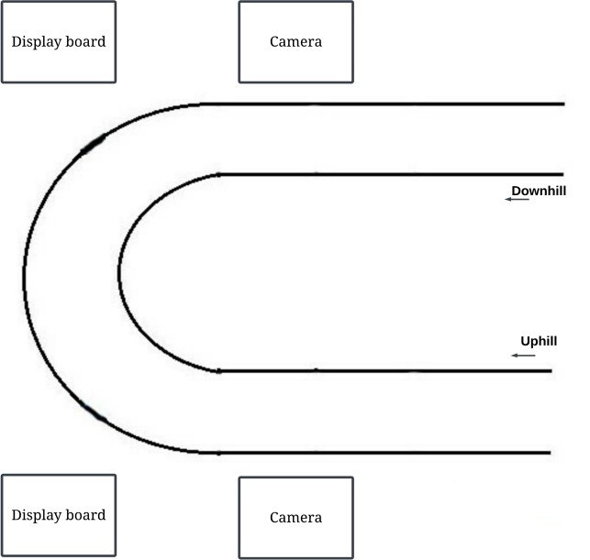

**Fig -1**: Block Diagram of Proposed System

The proposed system is used to detect the vehicles on one side of the hairpin and assist the vehicle coming opposite to it.

The aim of the proposed system is to classify different vehicles passing through one direction of the hairpin road and notify the vehicles coming from the opposite direction of the hairpin through a display board.

both the vehicle and the driver while also minimizing damage. vehicle-to-hub Communication can assist in obtaining it. Safety and avoiding crashes are the primary motivations for car-to-car communication systems. Car-to-Hub communication This technology isn't tailored to a certain vehicle or manufacturer.

With some modification, this may be used in any vehicle. The technology is developed in such a way that it may be used by a regular car drivers.

Automobiles have become one of humanity's greatest economic triumphs. The decision regarding speed and distance is passed on to the vehicle via a visual display.

## METHODOLOGY

* 1. **Power Supply Section**

A power supply circuit is a very basic circuit in learning electronics. The power supply which we will design here is very basic and it is a linear technology based design which

will go through each design step. The design of any circuit begins with a well-made general block diagram. It helps to design the sections of the circuit individually and then at the end put them together to have a complete circuit which is ready for use.

The four main sub blocks are: Transformer, Rectifier Circuit, Filter and Regulator

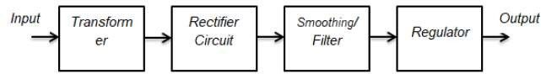

**Fig -2**: Block Diagram of Power Supply Section

## Input Transformer

A transformer is a device that is used to step up or step down the AC voltages level, keeping the input and out power the same. AC coming to your home has the voltage level of 220/120 V. We need the input transformer to step down the incoming AC to our required lower-level which is close to 5V (AC). This lower level is further used by other blocks to get the required 5V DC. Since we are using the main supply voltage which is too dangerous. We must never touch any of the terminals with bare hands or with bad instruments and must have a good and decent non-contact voltage tester and use it to always be sure of which line is the live wire coming to the transformer.

## Rectifier Circuit

A rectifier circuit is the combination of diodes arranged in such a manner that converts AC into DC voltage. The transformer still didn’t step down the voltage to 5V DC. The stepped-down voltage is still AC and need to convert it into DC for a good rectifier circuit. Without the rectifier circuit, it is not possible to have the required output 5V DC voltage.

## Filter

A capacitor filter is used when we need to convert a pulsating DC into pure or to remove distortion from signal. Nothing is ideal in practical electronics. The rectifier circuit converts the incoming AC to DC but it does not make it a pure DC. The output of the rectifier is pulsating and is called pulsating DC. This pulsating DC is not considered good to power up sensitive devices. The rectified DC is not very clean and has ripples and the job of the filter is to filter out these ripples and to make the voltage compatible for regulation. A rule of thumb is DC voltage must have less than 10 percent ripples to be regulated perfectly. The best filter in our case is the capacitor and the capacitor is used to charge the storing

device. Actually it can be best used as a filter. It is the most inexpensive filter for our basic 5V power supply design.

## Regulator

A regulator is the integrated circuit used to give a constant output voltage regardless of input voltage changes. Voltage regulation is very important because we do not need a change in output voltage when the load changes. An output voltage independent of the load is always required. The regulator IC not just makes the output voltage independent of varying loads, but also from line voltage changes.

## FLOWCHART

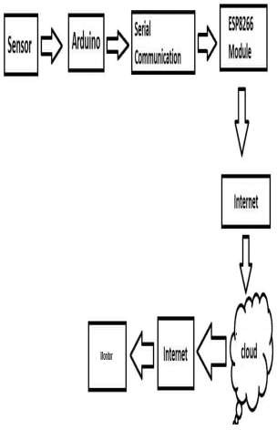

**Fig -3:** System Flowchart

For the real worldwide operated voltage distribution lines lights have been used from many years. In order to reduce the sensitivity of distribution networks to environmental influences voltage cables are highly used. Lights have been widely used in power distribution networks due to the advantages of circuit connection. lights system is a common practice followed in urban areas. While a fault occurs due to many reasons in the cable, at a time of removing or repairing process, there is difficulty in locating also nearby location of the fault. The system proposed in this project is used to find out the sub area of the fault and display it to the application over internet using Wi-Fi module.

.So the proposed system gives confidence to the drivers about the incoming vehicles in the deep curve and they are aware of the upcoming vehicle category. The proposed system reduces accidents in hairpin bends and there is less traffic congestion.

Every human being depends on vehicles in their daily lives. In addition, high-speed and rash driving are responsible for a high number of accidents. In hilly areas, the situation is even riskier. Because of the hairpin curves, automobiles have no visibility. The proposed system prevents accidents in hairpin curves and also reduces traffic congestion. It provides a real- time solution and vehicles can easily move through the hairpin curves.

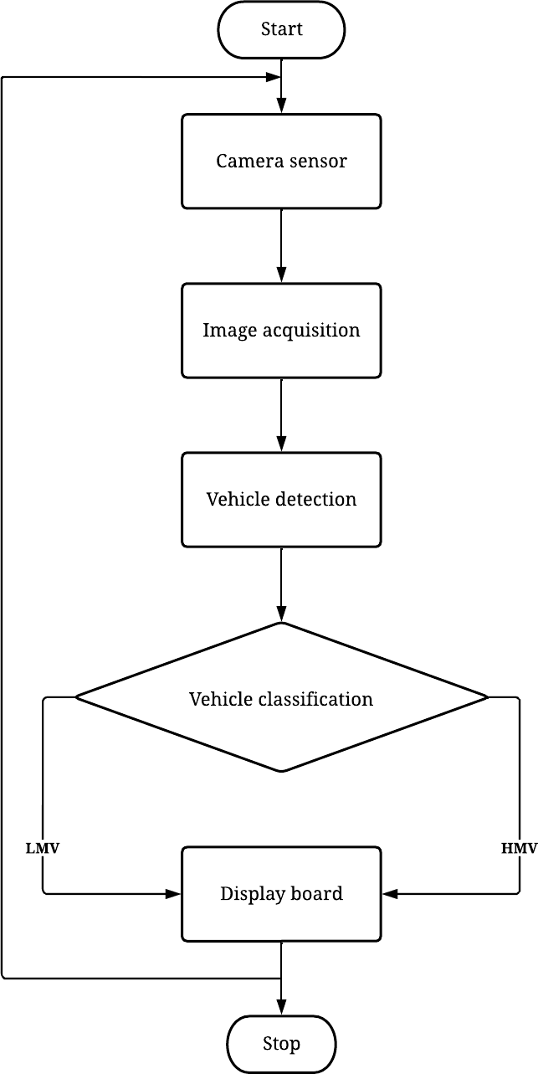

**Fig -4:** Flowchart of Working Process

Accidents are mostly caused by violations of traffic rules, negligence, and poor road conditions. Due to a lack of communication and zero visibility over the hairpin curves, vehicles travelling around these hairpin bends are extremely vulnerable to accidents. As a result, vehicles must use extreme caution when driving through hairpin curves. So the proposed system gives confidence to the drivers about the incoming vehicles in the deep curve and they are aware of the upcoming vehicle category. The proposed system reduces accidents in hairpin bends and there is less trafficcongestion

## HARDWARE AND SOFTWARE COMPONENTS

* 1. **Hardware Components**

### ATmega328 Microcontroller

The ATmega328 is a single-chip microcontroller. It has a modified Harvard architecture 8- bit RISC processor core. ATmega328 is low-powered and a low-cost micro- controller. ATmega328 has 32KB internal built-in memory. Atmega328 is faster as it uses lesser number of clock cycles for instruction execution.

### Arduino Nano

Arduino Nano is a small, compatible, flexible and breadboard friendly Microcontroller board, developed by Arduino.cc in Italy, based on ATmega328p / Atmega168. It comes with exactly the same functionality as in Arduino NANO but quite in small size. It comes with an operating voltage of 5V and the input voltage can vary from 7 to 12V.

### IoT Module (ESP8266)

The ESP8266 is a low-cost Wi-Fi microchip and 1 MiB (Mebibyte) of built-in flash, allowing single-chip devices capable of connecting to Wi-Fi. This small module allows microcontrollers to connect to a Wi-Fi network and make simple TCP/IP connections. The ESP8266 is a small WIFI module built around the ESP8266 chip that can connect microcontroller to the internet wirelessly for a very small cost. Interfacing the ESP8266 with an Arduino and perform some basic functions like connecting it to a WIFI network.

### Other Components

Step Down Transformer, Rectifier, PIR Sensor, Voltage Regulator, Switches and Connecting Wires.

## Software Components

### Arduino IDE

The Arduino integrated development environment (IDE) is a cross-platform application for (Windows, macOS, Linux). The Arduino IDE supports the languages C & C++. Arduino also simplifies the process of working with microcontrollers.

### Embedded C

Embedded C is a set of language extensions for the C programming language. It addresses commonality issues that exist between C extensions for different embedded systems. It includes a number of features not available in normal C, such as fixed-point arithmetic, named address spaces and basic I/O hardware addressing. Embedded C uses most of the syntax and semantics of standard C.

## RESULTS

The proposed system helps with accident avoidance and effective traffic management in hairpin curves. This system consists of two cameras and two display boards. To demonstrate the system, it uses webcams for reading input and the Python GUI library Tkinter for display. This system is accurate for vehicle classification. It gives the preference for a vehicle according to its class.

## APPLICATIONS AND ADVANTAGES

* 1. **Applications**
     + Monitoring vehicle crossing.
     + Hairpin curves indication.
     + Hills station use smart lights.
     + PIR sensor use dectecting

## Advantages

* + - Avoid Accident
    - Increase Road safety
    - Reducing the risks of people getting involed in accidents
    - Ensure safe work environment
    - Any object moving sensor will be trigering

## CONCLUSIONS

People have become much more reliant on transportation systems in recent years, and transportation systems themselves confront both opportunities and limitations. The world's population continues to rise, posing a significant challenge to transportation management systems.

The vehicle moving through hairpin bends are very much susceptible to accidents due to lack of communication and zero visibility over the hairpin curves. Hence, drivers must be extremely cautious while driving in hairpin curves.

The proposed system aims to reduce traffic congestion and prevent collisions in hairpin curves as much as possible, allowing for easy vehicle movement in hilly areas.So the drivers can easily drive through hairpin curves and accidents can be prevented.

It is not easy task to design this system using PIR sensors where PIR is generally used for the motion detection. We have done coding in such a way that little movement of the human body is detected by the sensor. We have made some time delay and adjusted the sampling period for the sensor output for the precise detection for this system.

## ACKNOWLEDGEMENT

We would like to extend our sincere thanks and gratitude to our honourable CEO, Prof. M.

MALA M.A., M.Phil., and our Director Dr. M.RAMALINGAM B.E., M.S.,PhD., and our

Principal, Dr. RAMESH, for providing us all the facilities and resources required to complete

our project successfully.

We find no words to express our deep sense of gratitude to Dr. K. SUNDARAMOORTHY

M.E., PhD., Professor and Head, Department of Information Technology, for being a constant

source of inspiration throughout the course of our project.

We thank our Project Coordinator Ms. K. PUSHPAVALLI, Assistant Professor, for their

advice and assistance in keeping our progress on schedule.

We express our deep sense of gratitude to our supervisor, Ms. M.A. CHRISTY GRACE,

Assistant Professor of our Department, for his valuable guidance and useful suggestions,

which helped us in completing this project successfully.

Our grateful thanks are also extended to all our department faculty members for their valuable

technical support on this project. Finally, we thank almighty, our parents and friends for their

constant encouragement without which this project work would not be possible.

## REFERENCES

1. Kunal Yogeshkumar Parikh, Brajesh Kumar and Vijay Raval, “GSM Based PIR Distance Locator”, International Journal for Scientific Research & Development (IJSRD), Vol 6, Issue 4, 2018, pp 1174- 1176.
2. B.Y.V.N. R Swamy, D. Rama krishna, CH. Purna chandu, K.Venkatesh and A. Sasidhar Reddy, “LDR”, International Journal for Research in Applied Science & Engineering Technology (IJRASET), IC Value: 45.98, SJ Impact Factor: 6.887, Vol 6, Issue 3, March 2018, pp 3060-3064.
3. Summi Thomas, A.Vimenthani and Kaleeswari, “Automatic underground cable fault locator using GSM”, International Journal of Advanced Research Trends in Engineering and Technology (IJARTET), Vol 4,Issue 19, April 2017, pp 260-265.
4. Abhay Sharma, Akash Mathur and Rajat Gupta, “Underground Cable Fault Distance Locator”, IJAREEIE, Vol. 6, Issue 4, April 2017, pp 1260-1264.
5. Faizan Mohammad Yakub and Dinesh Rojatkar, “Arduino Cable Fault Detector A Survey”, Vol 4, Issue 1, January 2017 JETIR, pp 2349-5162.
6. Akash Jagtap, Jayesh Patil and Bhushan Patil, “Arduino based Underground Cable Fault Detection”, IJREAM, Vol 3, Issue 4, May 2017, pp 88-92.